Contemporary Issues - Instructions for the online course
The link to take you straight to the registration page on the ASA website appears below.
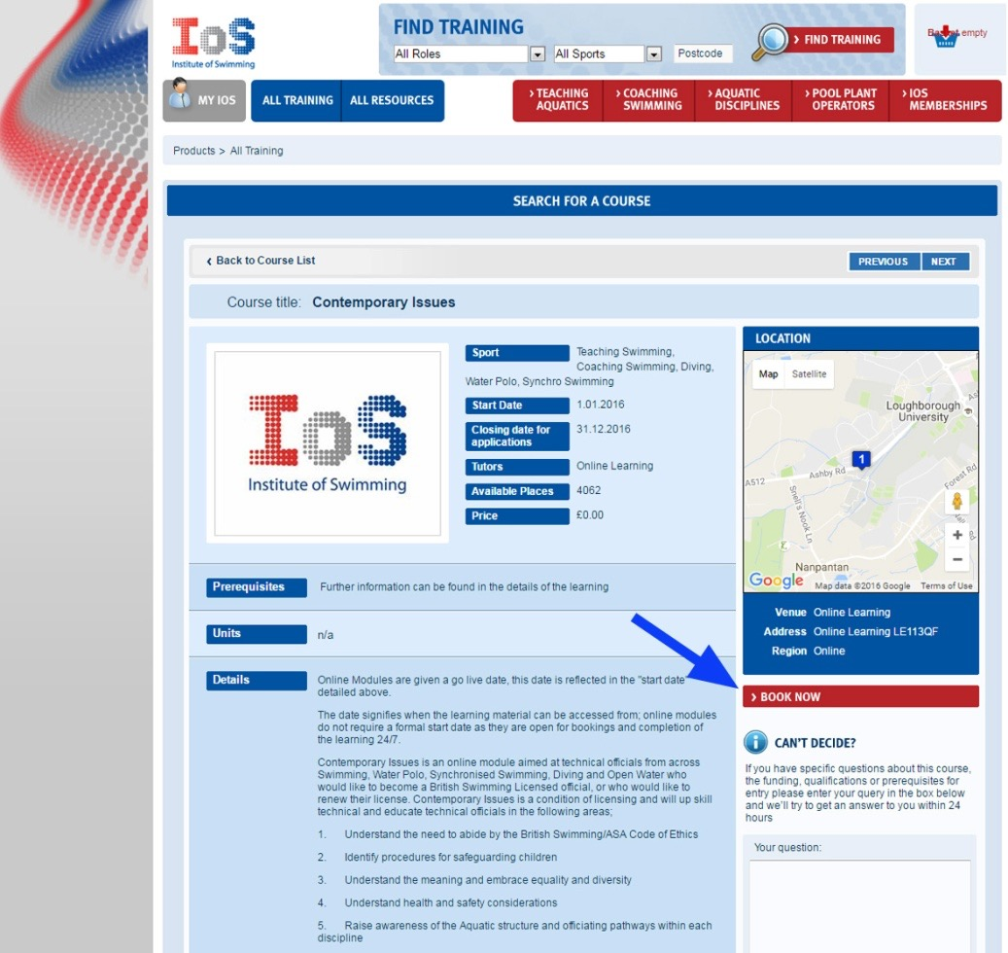
http://www.theiosonline.com/Courses.aspx?itemid=27504&itemtitle=Contemporary%20Issues&sitesectionid=43&sitesectiontitle=Qualifications&destination=Courses.aspx%3fsitesectionid%3d43%26sitesectiontitle%3dQualifications%26region%3d%26cType%3d2%26page%3d2&cType=2&itemType=cpd_seminar

- Either control click on the link or paste it into Explorer/Chrome or whatever browser you are using, Safari for Mac users.
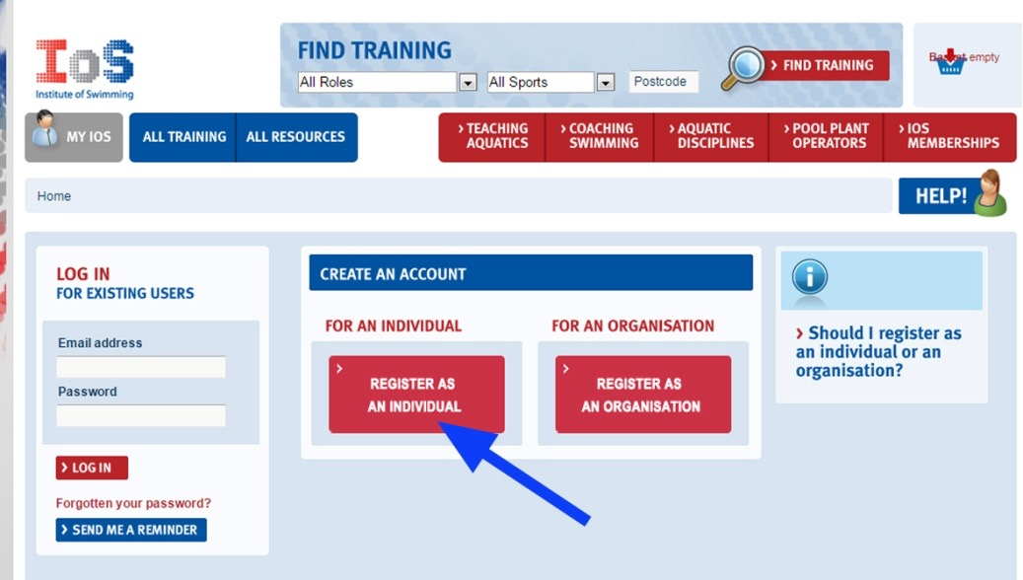
- Click the book now tab then register as an individual.
- When you have registered click on blue tab ‘All training’
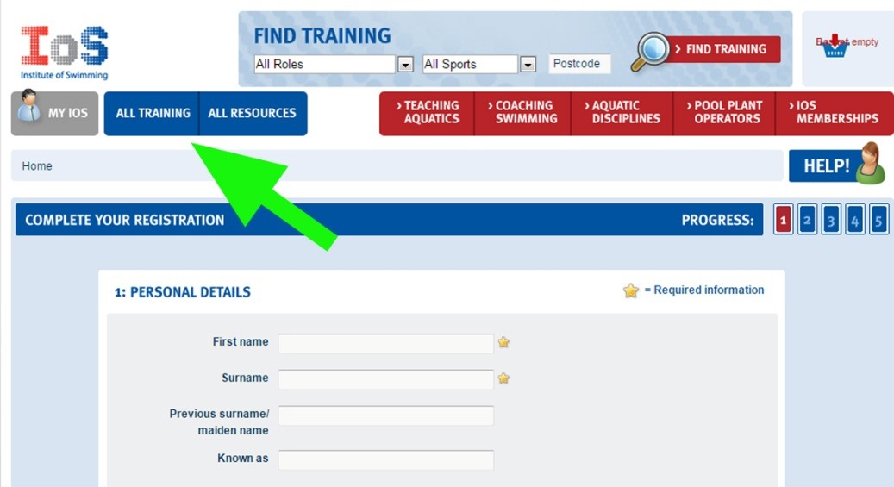
- Then on the next page on ‘search for a course’ click on ‘ONLINE LEARNING’ Then contemporary Issues and it adds to your basket (Just like shopping on Amazon!)
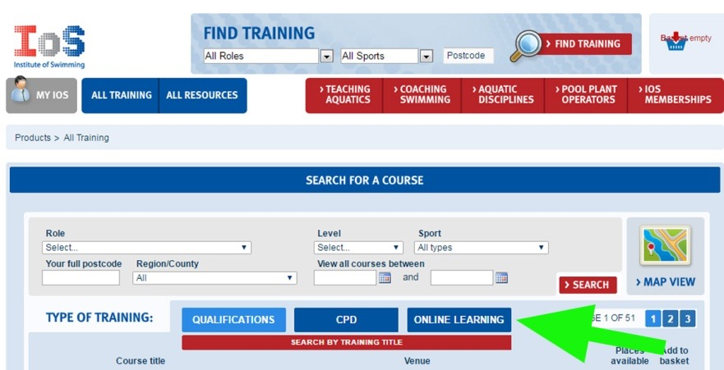
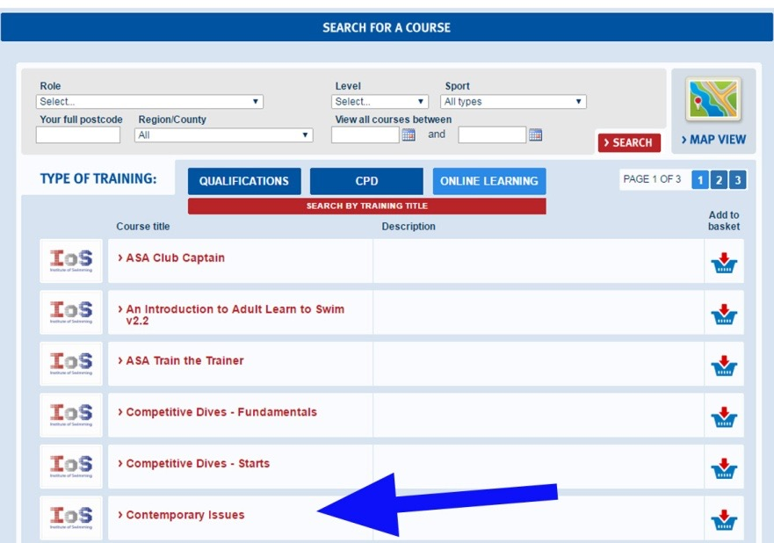
- On the Contemporary Issues page click the red ‘BOOK NOW’ button and you should be under way!

When you have completed the course your score will appear on the screen.
There has been a problem with a few passes not getting registered and once the screen with the pass mark on it goes you cannot get it back. I suggest the following:
When your score is on the screen press the ‘prt sc’ (print screen) key, it is on the top right normally in the row of function keys.
This will hold the screen image on the clipboard
Apple users
Press Command (⌘)-Shift-3

Open a new word document and paste the screen image into the document, this can be done with control V or from the top menu (home tab on word, left hand side).
Save the word document and print it if you want to, that provides evidence that you have completed the course successfully.
As Alexander Orlov the Meerkat says, ‘Simples’

